

CAMBRIDGE A LEVEL PROGRAMME
Semester One Examination June 2009
(Jan 2009 Intake)

Monday 8 June 2009 1.30 pm – 2.30 pm

PHYSICS 9702/01
Paper 1 Multiple Choice
Multiple Choice Answer Sheet
Data Booklet

PAPER 1 Multiple Choice 1 hour

Candidates answer on the Question Paper
Data Booklet

READ THESE INSTRUCTIONS FIRST

Write in soft pencil
Write your name, class and student number on the answer sheet in the spaces provided.
Do not use staples, paper clips, highlighters, glue or correction fluid.

There are forty questions in this paper. Answer all questions. For each question there are four possible answers A, B, C and D.
Choose the one you consider correct and record your choice in soft pencil on the separate answer sheet.

Read the instructions on the answer sheet very carefully.

Each correct answer will score one mark. A mark will not be deducted for a wrong answer.
Any rough working should be done in this booklet.

Class | Student Number | Name

This document consists of 14 printed pages.

© Taylor’s University College Subang Jaya 2009 [Turn over
1 Which of the following could be measured in the same units as torque?

A (mass) / (acceleration)
B (mass) x (acceleration) x (distance)
C (force) / (distance)
D (force) x (acceleration)

2 The notation ns is used as an abbreviation for a certain unit of time.
What is the name and value of this unit?

 | Name | Value
A | microsecond | 10⁻⁶
B | microsecond | 10⁻⁹
C | nanosecond | 10⁻⁶
D | nanosecond | 10⁻⁹

3 A thermometer has a smallest division of 1°C. This thermometer is used to measure temperature rise in pure water from 25 °C to boiling.
What is the percentage uncertainty in the measurement of the temperature rise?

A 0.5 % B 0.8 % C 1.3 % D 1.7%

- In an experiment to measure the density of steel, a steel sphere was used. The following measurements were obtained:

Mass of the sphere = 530 mg ± 1 mg
Diameter of the sphere = 0.51 cm ± 0.01 cm

Estimate the percentage error in the calculated value of the density of steel.

A 1% B 2% C 4% D 6%

- When given a slight push, a toy car moves freely with constant velocity down a plane inclined at 20º to the horizontal. If the mass of the car is 0.5 kg, find the force parallel to the inclined plane for pulling the car up the plane with constant velocity.

A 1.7 N B 3.4 N C 4.7 N D 6.7 N

6
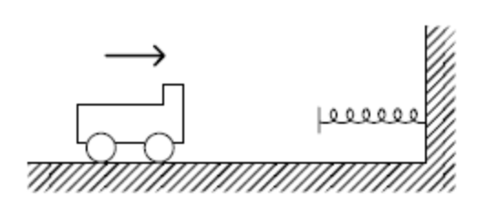
A trolley travels with constant velocity to the right on horizontal ground and collides with a light helical spring attached to a wall fixed to the ground (earth) as shown. At the instant that the trolley comes momentarily to rest during collision, what has happened to the initial momentum of the trolley?

A It has been transferred to the earth.

B It has been stored in the spring.

C It has been dissipated as sound and heat.

D It has been destroyed by the friction due to the ground.

- Three bombs are released from a bomber flying horizontally with constant velocity to the right. They are released from rest (relative to the bomber) one by one at one-second intervals. Neglecting air resistance, which of the following diagrams correctly shows the positions of the bomber and the three bombs at a certain instant?

A B
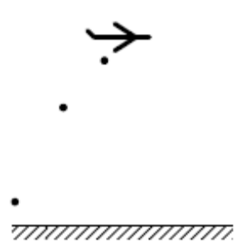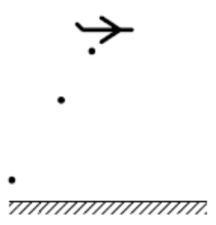

C D
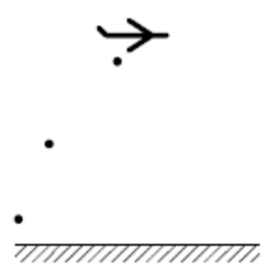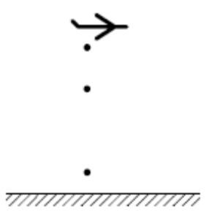
- A micrometer screw gauge is used to measure the diameter of a copper wire. The reading with the wire in position is shown in diagram 1. The wire is removed and the jaws of the micrometer are closed. The new reading is shown in diagram 2.

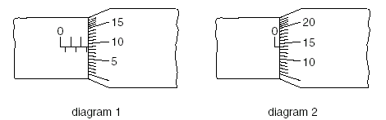

What is the radius of the wire?
diagram 1
A 1.23 mm B 1.225 mm C 1.36 mm D 1.360 mm

diagram 2

- A small car of mass 800 kg, is being driven in foggy condition. In this situation the maximum deceleration of the car is 7.5 ms⁻². While driving at the constant speed of 21 ms⁻¹, the driver sees a stationary car 30 m ahead and takes 0.40 s to react. Determine the speed at which the car will hit the stationary car.

A 3.0 ms⁻¹ B 5.2 ms⁻¹ C 10.8 ms⁻¹ D 12.3 ms⁻¹

10
F₂
F₁

The resultant of two forces F₁ and F₂ acting at a point can have a minimum value of 1 N and a maximum value of 7 N. When the two forces act at right angles to each other, the magnitude of their resultant is

A 3 N B 5 N C 6 N D √50 N

11
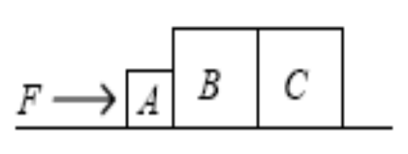
Three blocks A, B and C of masses m, 2m and 2m respectively are placed on a smooth horizontal ground as shown in the figure above. A constant horizontal force is applied to block A so that the three blocks move with the same acceleration towards the right. What is the resultant force acting on block B?

A F/5 B F/3 C 2F/5 D 3F/5

- An object of mass m slides with constant acceleration a down a plane making an angle θ with the horizontal. The frictional force acting on the object is

A mg - ma
B mg - ma sin θ
C mg sin θ- ma
D (mg - ma) sin θ

- Which of the statement below explains the presence of pressure in a container?

A Collisions between air molecules in the container.
B Collisions between air molecules in the container and container’s walls.
C Rate of change of momentum between molecules during collisions.
D Rate of change of work done between molecules and container’s wall during collisions.

- For a body released from rest and falling freely under gravity, the kinetic energy is proportional to the

- product of the time of fall and the distance
- speed
- square of the distance fallen
- square of the time of fall

  - Two bodies, moving along the same straight line, collide. After impact the bodies adhere and continue to move along the same line. Which of the following statements is correct?
- The net change in momentum is zero.
- The net change in kinetic energy is zero.
- The collision is elastic.
- The total energy may change.

  - Which of the following pairs of forces, acting on a rod, constitutes a couple?

F 2F F
F

F F F

F

A B C D

  - A uniform beam of weight 100 N is 5.0 m long and is supported on a pivot situated 2.0 m from one end. When a load of weight W is hung from that end, the beam is in equilibrium, as shown in the diagram.

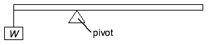

What is the value of W ?

A 25 N B 35 N C 75 N D 100 N

  - A twig from a tree drops from a 400 m high cliff onto a beach below. During its fall, 36% of the twig’s energy is converted into thermal energy. What is the speed with which the twig hits the beach?

A 32 ms⁻¹ B 57 ms⁻¹ C 71 ms⁻¹ D 89 ms⁻¹

  - A motorist travelling at 10ms⁻¹ can bring his car, of mass 1000 kg, to rest uniformly in a distance of 10 m. What is the average power of the brakes in bringing the car to rest?

A 4 kW B 20 kW C 25 kW D 40 kW

  - Which of the following expressions defines power?

A force × distance moved in the direction of the force
B force × velocity
C work ÷ time taken
D work × time taken

- The pressure on the top and bottom surface of an object of mass 0.5 kg immersed in a liquid of density 800 kgm⁻³ are 1.05 x 10⁵ Pa and 1.1 x 10⁵ Pa. The surface area of the top and the bottom is the same, which is 30 cm². Which statement below is correct?

A the upthurst on the object is 4.9 N
B the upthrust on the object is 10.1 N
C the upthrust is equals to 15.0 N
D the upthrust is equals to 19.9 N

22 Dust particles appeared to linger in the air for a long time before they finally settle down. Which of the following best explains this observation?

A the dust particles are light and hence take a long time to go down
B the dust particles are attracted to each other, hence overcoming the gravity that acts downward
C the dust particles are bombarded by high speed air molecules in all direction.
D the dust particles collide with each other and hence move in zig zag motion.

23 A spring hung from a fixed support extends by 5 cm when a load of mass 200 g is attached to the other end and comes to rest. Which statement is correct?

A the spring constant is 40 Nm⁻¹ and the energy stored is 50mJ
B the spring constant is 4 Nm⁻¹ and the energy stored is 0.25 mJ
C the spring constant is 40 Nm⁻¹ and the energy stored is 0.25 mJ
D the spring constant is 4 Nm⁻¹ and the energy stored is 50 mJ

24 What is represented by the gradient of a graph of stress (vertical axis ) versus strain (horizontal axis ) ?

A the force contant
B elastic limit
C energy stored per unit volume
D the Young Modulus
25 A metal wire is stressed gradually until it fractures. Which stress-strain graph represents the deformation of the metal wire?

A B
Stress/Pa
strain
Stress/Pa
strain
Stress/Pa
strain
Stress/Pa
strain

C D

- In a ripple tank experiment, water ripples are continuously produced from a dipper connected to a vibrator. The waves reach a floating cork 1 metre away. The cork bobs up and down 10 times per second. The speed of the water ripples is 5 ms⁻¹. Determine the number of wavelength between the dipper and the cork.

A 0.5 B 2 C 5 C 10

27 An idealized pulse of length 1.0m travels on a stretched string with a speed of 5ms⁻¹. The pulse just reaches point P at the moment shown. Q is a point 1 metre away from P. Which graph shows how the displacement of Q varies with t for the next 0.5 seconds?

P
Q
pulse

y
t
0.1
0.2
0.3 .31
0.4
0.51
t
y
0.1
0.2
0.31
0.4
0.51
t
y
0.1
0.2
0.31
0.4
0.51
t
y
0.1
0.2
0.31
0.4
0.51
A B

C D

- A progressive sound wave produces a vibration of amplitude 2 mm to a microphone diaphragm placed at 2 m from the point source. If the power of the source is made four times larger, what is the amplitude of vibration of the diaphragm placed at 4 m away?

A 1 mm B 2 mm C 4 mm D 8 mm

- Which of the following sequence shows an increasing order of wavelength?

A Radio wave, microwave, UV
B Gamma, radio, infrared
C Visible, infrared, ultraviolet
D X-ray, visible, radio wave

30 A beam of yellow light and red light are directed towards a diffraction grating. The 2nd order of red light overlaps with the 3rd order of yellow light. What is the ratio of the maximum order of yellow light to the maximum order of the red light?

A 1/2 B 2/3 C 1 D 3/2

- Which of the statements regarding stationary wave is correct?

A the distance between 2 successive antinodes is equal to a wavelength
B all particles in a stationary wave have the same amplitude
C nodes are points where the displacement is maximum all the time
D formed by two identical waves traveling in opposite direction and overlap

- Which of the diagram below shows the field lines between the metal plates and the force acting on a proton correctly?
+V
0 V
+V
A B

0 V
field lines

force

0 V
+V
0 V
+V

C D

- Which graph correctly shows the variation between the electric field strength, E, and the separation of the parallel metal plates, d ?

A B
E
d
E
d

C D
E
d
E
d

34 Which of the following methods cannot be used to measure the emf, E of a battery which has an internal resistance, r ?

A connecting a voltmeter across the terminal of the battery and obtain the reading
B connecting the battery across a pre-calibrated Cathode Ray Oscilloscope
C connecting the battery to a pre-calibrated potentiometer and find the balanced length
D extrapolate the graph of V across the external resistance vs I to find the y-intercept

- Which of the following networks containing four identical lamps of rating
240V, 60 W connected to a p.d. of 240 V produce the highest total power?

A B

C D

36 Three resistors R₁, R₂ and R₃ are connected in series to an e.m.f.10 V of negligible internal resistance. The voltmeter readings are V₁, V₂ and V₃ respectively. If V₁ = 2V₂ and V₂ = 2V, what is the ratio of resistance R₁ : R₂ : R₃ ?
V₃
V₂
V₁
R₁
R₂
R₃
10V

A 1 : 1 : 1 B 2 : 1 : 2 C 2 : 1 : 7 D 2 : 3 : 5

37 The circuit below shows the current I₁, I₂, I₃ flowing in three resistors of equal resistance 10 Ω. The circuit has been labeled A, B, C, D, E, F at various points. Taking all possible loops in anticlockwise direction, which statement below concerning Kirchoff’s laws is correct?

10 V
10Ω
5V
10Ω
10Ω
I₂
I₃
A
B
C
D
E
F

I₁

A the total e.m.f. in loop ABEF is 5V
B the total p.d. in loop ABEF is 10I₁ + 10 I₂
C I₁ + I₂ – I₃ = 0
D total p.d. in loop BCDE = 10 I₃ – 10 I₂

38 The circuit below shows a potentiometer used to measure the e.m.f. E₁ of a cell. The resistance of the rheostat, R is increased. Which of the following describes the changes correctly?

5V
R
E₁
l
C
B
A

A p.d. across AB decreases and V_{AC}/l decreases
B p.d. across AB decreases and V_{AC}/l increases
C p.d. across AB increases and V_{AC}/l decreases
D p.d. across AB increases and V_{AC}/l increases

39 In an experiment to investigate the nature of the atom, a very thin gold film was bombarded with α - particles.
What pattern of deflection of the α - particles was observed?

  - No α - particle was deflected through an angle greater than 90º angle.
  - All α - particles were deflected from their original path.
  - Most α - particles were deflected through angles greater than 90º angle.
  - A few α - particles were deflected through angles greater than 90º angle.

40 A high energy α - particle collides with a 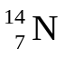 nucleus to produce a 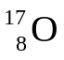 nucleus. What could be the other products of this collision?

A a γ - photon alone
B a γ - photon and a β - particle
C a γ - photon and a neutron
D a γ - photon and a proton

